1. Subculture

Materials
- PBS
- Trypsin-EDTA (0.5X)
- DMEM with 10% FBS

Procedures
- Aspirate the cell medium from the dishes and wash the cells with 3-5ml of room-temperature PBS for 2 times to remove any residual growth medium.
- Incubate cells with 0.5X trypsin-EDTA (0.3 ml for small dish, 0.5 ml for medium dish and 1 ml for large dish) keep in 37ºC for 1-2 min (depend on cell line).
- Once the cells have begun to detach, pat the dish gently then add 10%FBS DMEM which contains sufficient FBS to inhibit trypsin activity. (2 ml for small dish, 3 ml for medium dish)
- Pipet medium to blow cells into suspension then transfer them into a centrifugation tube.
- Centrifuge at 1000rpm for 3 min. (keep the balance of centrifuger).
- During the centrifuging period, take new tissue cultured dishes. Label the dishes with cell name, passage, date, initials of your name. Add fresh 10%FBS DMEM to dish (2 ml for small dish and 5 ml for medium dish).
- Tilt the tube and aspirate the supernatant with vacuum tip, resuspend the cell pellet with 3 ml 10%FBS DMEM by pipetting up and down to break cell-cell aggregation. Split the cells to labeled dishes based on different needed;
- Swirl the dish gently to allow the cells to spread evenly throughout the dish.
- Keep the cell dishes in the incubator supplemented with 5% CO₂ at 37ºC.

Note
Cell should be subcultured when they reach 80-90% confluence. If the cells are allowed to reach 100% confluence, growth arrest can result with a decrease in the subsequent proliferative potential of the cells.

2. Plate cell

Materials
- Ensure the haemocytometer and the cover-slip is clean using 70% ethanol.
- hand tally counter

Procudure
  - Make sure the cell suspension to be counted is well mixed. An accurate cell count is obtained, a uniform suspension containing single cells is necessary. It is important to disperse the cells thoroughly by pipetting up and down.
  - Approximately 10 µl of cell suspension will be required to charge one chamber of the hemocytometer.
Carefully fill the haemocytometer by gently resting the end of the tip at the edge of the chambers. Take care not to overfill the chamber. Allow the sample to be drawn out of the pipette by capillary action, the fluid should run to the edges of the grooves only. Re-load the pipette and fill the second chamber if required.
  - View the cells under the microscope and using a hand tally counter. Focus the microscope on one of the 4 outer squares in the grid. Count the number of cells in this area of 16 squares.
Count all the cells in the four 1 mm corner squares. If there are too many or few cells to count, repeat the procedure either concentrating or diluting the original suspension as appropriate.
  - Move the haemocytometer to another set of 16 corner squares and carry on counting until all 4 sets of 16 corner squares are counted. The haemocytometer is designed so that the number of cells in one set of 16 corner squares is equivalent to the number of cells x 10⁴ / ml.

Therefore, to obtain the count:
The total count from 4 sets of 16 corner = (cells / 4) x 10⁴ / ml X volume ml to adjust for the dilution in DMEM

As an example:
If suspend cell with 3 ml DMEM and the total cell of 4 squares count is 420:
The cell density is 420/4 x10⁴=105 x 10⁴=1.05 x 10⁶/ml Total cell amount: 1.05 x 10⁶/ml x 3 ml= 3.15 x 10⁶/ml
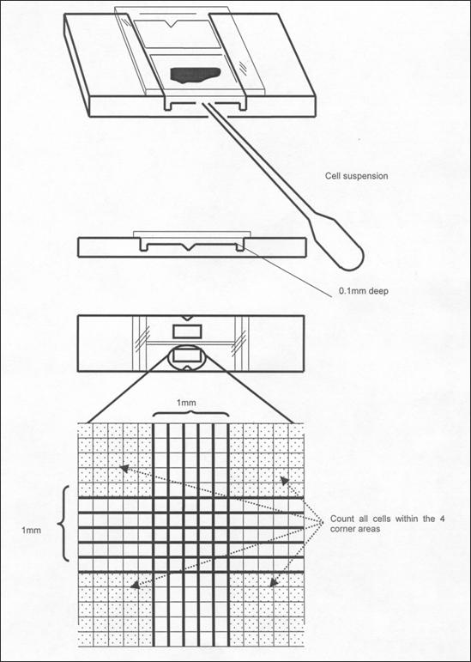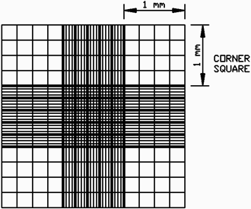

3. Transfection with Lipofectamin 2000 reagent

Materials
- Lipofectmine 2000 transfection reagent (1mg/ml)
- Opti-MEM Medium
- 10%FBS DMEM without antibiotics

Procedure
  - The day before transfection, plate cell depending on the needs of your experiment.
  - 1 µg DNA gently mixed into 100 µl Opti-MEM/dish, gently tap the tip of vial to mix.
  - 2 µl lipofectamine mixed into 100 µl Opti-MEM/dish; gently tap the tip of vial to mix.
  - Incubate for 5 min at room temperature.
  - Add lipofectamine-OptiMEM to tube containing DNA-OptiMEM, mix gently and drop by drop on its wall.
  - Incubate at room temperature for 20 min to allow DNA-lipofectamine complexes to form.
  - During the incubation period, wash the cells with 2ml of room-temperature PBS for 1 time to remove antibiotics.
  - Add the DNA-lipofectamine complexes (200 µl) directly to each dish, gently swirl to mix.
  - Incubate for 5.5 hr at 37ºC in a CO₂ incubator.
  - Wash the cells with 2ml of room-temperature PBS for 1 time to remove complexes and change medium to 0.5% FBS DMEM if required or 10% FBS with antibiotics.

Note
For transfection of larger number of cells, scale up all the reagents (cells, media, DNA, Lipofectamine™ 2000 and plate size) proportionately to the number of cells transfected.

4. Fibronectin coating

Materials
- Fibronectin, from bovine plasma (1mg/ml)
- PBS
- Glass-bottom dish

Procedure
  - Dilute Fibronectin with PBS depending on the needs of your experiment.

As an example:
If Fibronectin concentration is 10µg/ml and need coat 4 dishes: 8µl FN + 792µl PBS = 800 µl = 200 µl/dish x 4 dishes
  - Mix well and coat on the center of dish.
  - Incubate for 4 hr at 37ºC in a CO₂ incubator.

5. Pass cell on glass-bottom dish

Procedure as cell subculture

Dilute cells with cell culture medium depending on the needs of your experiment.

Aspirate the excess FN solution on the glass-bottom dish before pass cells onto it.

Only pass the cells to the center glass well of the dish (~300 µl). When finish passing, leave the dish in the incubator and add 1-2 ml medium when the cells are fully attached. (It takes approximately 30 min-1 hr for cells to attach).

6. Imaging

